Discussion Assignment 6
Part 1:
First, create 3 equations of the form $ax+by+cz=d$, where $a$, $b$, $c$, and $d$ are constants (integers between – 5 and 5). For example, $x+2y-z=-1$. Perform row operations on your system to obtain a row-echelon form and the solution.
System of linear equations
$2x+4y+5z=5$
$2x+3y-3z=1$
$2x+4y+4z=4$
$$\left(\begin{matrix}2 & 4 & 5 \\ 2 & 3 & -3 \\ 2 & 4 & 4\end{matrix} | \begin{matrix}5 \\ 1 \\ 4\end{matrix}\right)$$
$$\begin{matrix}=\frac{1}{2}R_{1}→ & \left(\begin{matrix}1 & 2 & \frac{5}{2} \\ 2 & 3 & -3 \\ 2 & 4 & 4\end{matrix} | \begin{matrix}\frac{5}{2} \\ 1 \\ 4\end{matrix}\right)\end{matrix}$$
$$=\begin{matrix}2R_{1}-R_{2}→ & \left(\begin{matrix}1 & 2 & \frac{5}{2} \\ 0 & 1 & 8 \\ 2 & 4 & 4\end{matrix} | \begin{matrix}\frac{5}{2} \\ 4 \\ 4\end{matrix}\right)\end{matrix}$$
$$=\begin{matrix}{2R}_{1}-R_{3}→ & \left(\begin{matrix}1 & 2 & \frac{5}{2} \\ 0 & 1 & 8 \\ 0 & 0 & 1\end{matrix} | \begin{matrix}\frac{5}{2} \\ 4 \\ 1\end{matrix}\right)\end{matrix}$$
$$x+2y+\frac{5}{2}z=\frac{5}{2}$$
$$y+8z=4$$
$$z=1$$
$$y+8\left(1\right)=4$$
$$y=4-8$$
$$y=-4$$
$$x+2(-4)+\frac{5}{2}(1)=\frac{5}{2}$$
$$x-8+\frac{5}{2}=\frac{5}{2}$$
$$x=8$$
Solution = $\left(8,-4,1\right)$
Go to the 3D calculator website GeoGebra: www.geogebra.org/3d?lang=pt and enter each of the equations.
GeoGebra graph
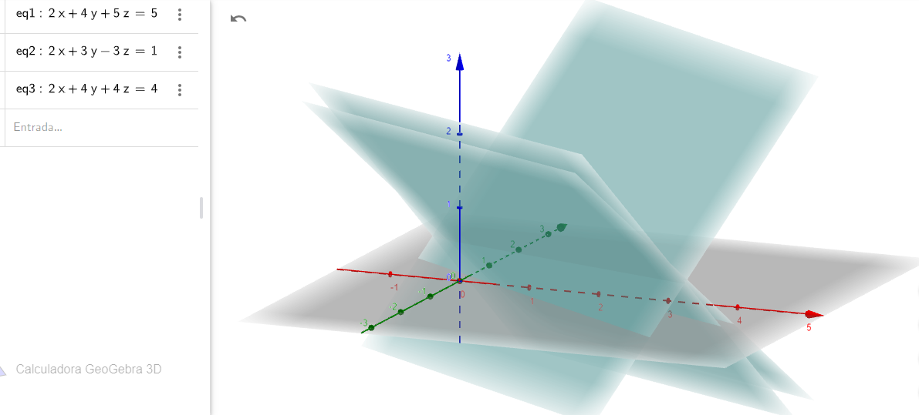
It is evident from the graph above that GeoGebra has the capacity to study three system of linear equations with three variables where the solution is located where the three lines intersect as shown in the graph.
Part 2:
Give an example with 2 equations as simple as possible with 3 variables (at least 1 being non-linear; keeping z to the one power on both equations) and describe the potential of GeoGebra to study nonlinear systems.
$2x+3y-z=7$
$x^{2}+y+z=5$
GeoGebra graph
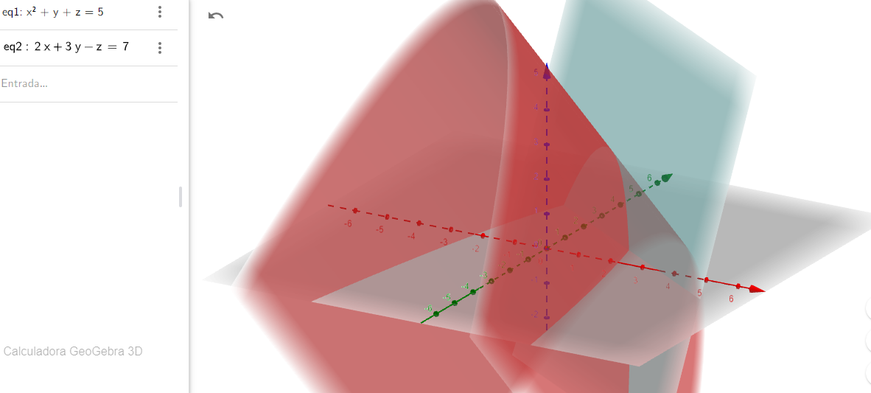
It is evident from the graph above that GeoGebra may not have the potential to study nonlinear systems. This is because at least three system of equations are required to solve for the three variables. Generally, if there are more equations than variables, we call the system "overdetermined" and it almost always has no solution. If there are more variables than equations, we call the system "underdetermined" and the system has either no solution or infinite solutions. For this case, the system is "overdetermined" leading to no solution, thus explaining why GeoGebra may not have the potential to study nonlinear systems. For that reason, it is not possible to identify from the GeoGebra where the linear and non-linear system of equations intersect.

